LAB 3 REPORT
NAME: IBRAHIM ALSHAYEA
ID: 202176470
DATE: 2/6/2024

TASK 1:
Nothing to do, just download and compile the program.
The output for the DLLTest class:
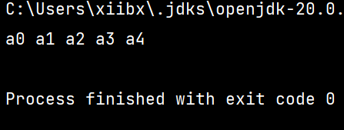

Task 2:
Write a method public void printReverse().
Firstly. I declared the method. Then I created a temporary variable that is equal to the tail so that we can start from the tail. Then, I created a traversal for loop so that I print the first element from the right and then change the temporary variable to be the next element from the right using prev instance.

Output:
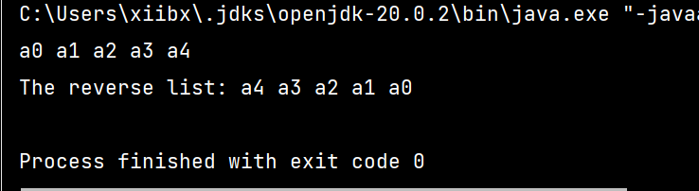

Code:
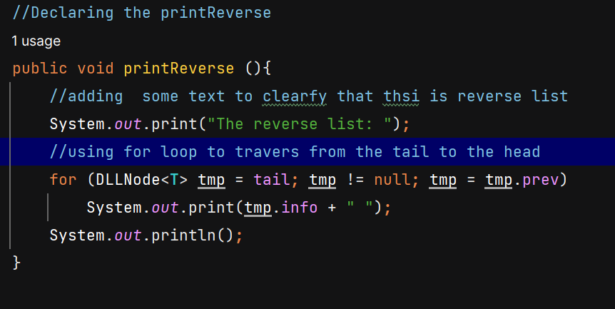

Task3:
I implemented a method called delete7() to remove the 7th element from a doubly linked list. It starts by checking if the list is empty. Then, it moves through the list, counting elements and switching direction when needed. When it finds the 7th element, it deletes it and stops.

Output:
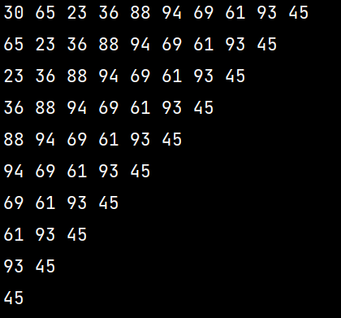

Code:
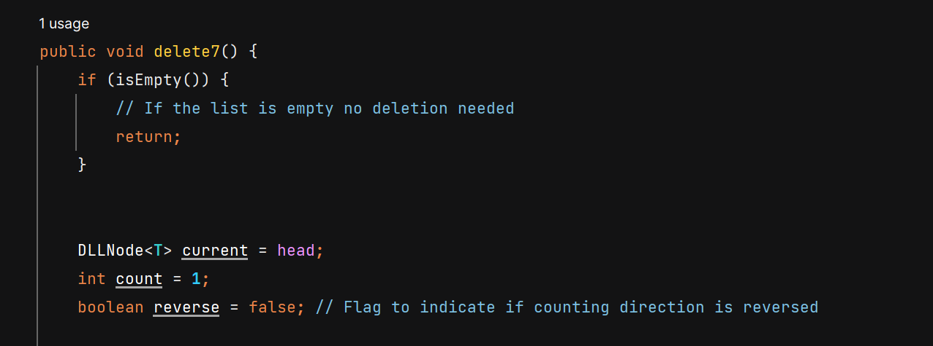
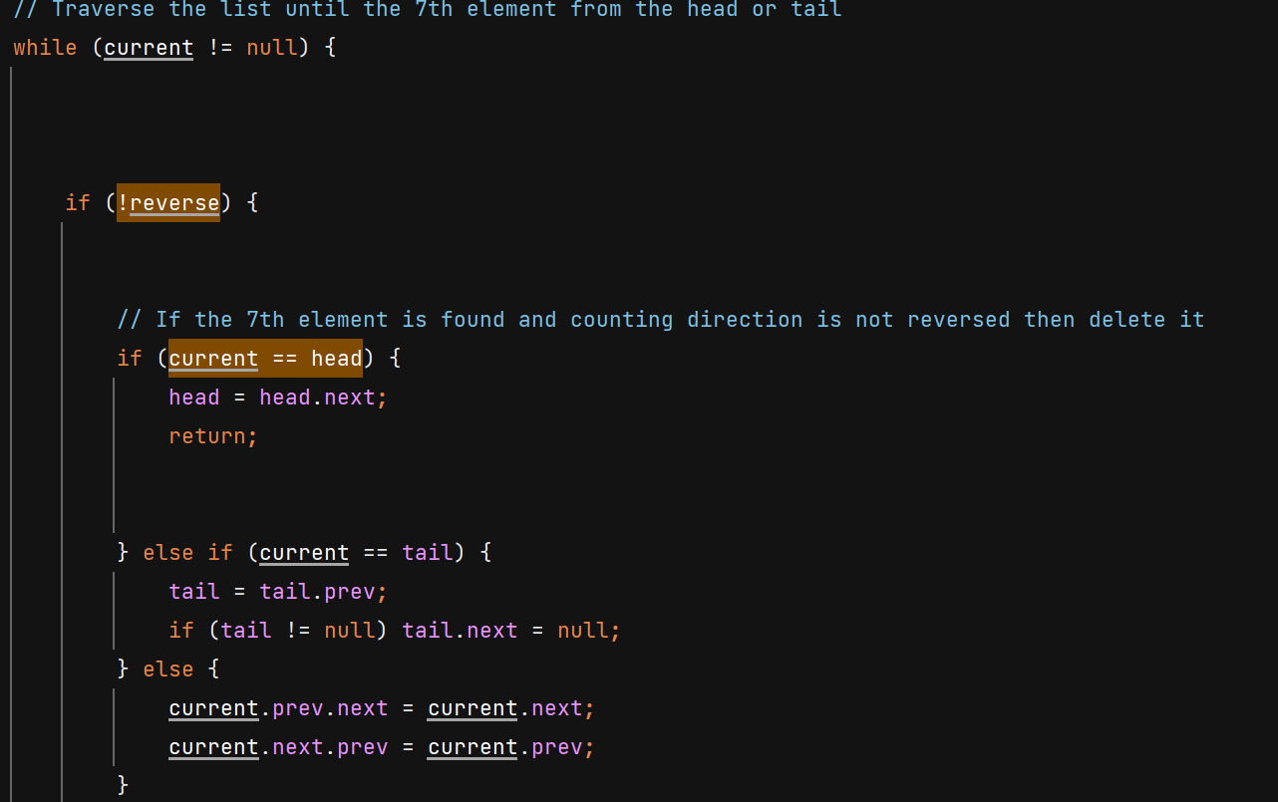
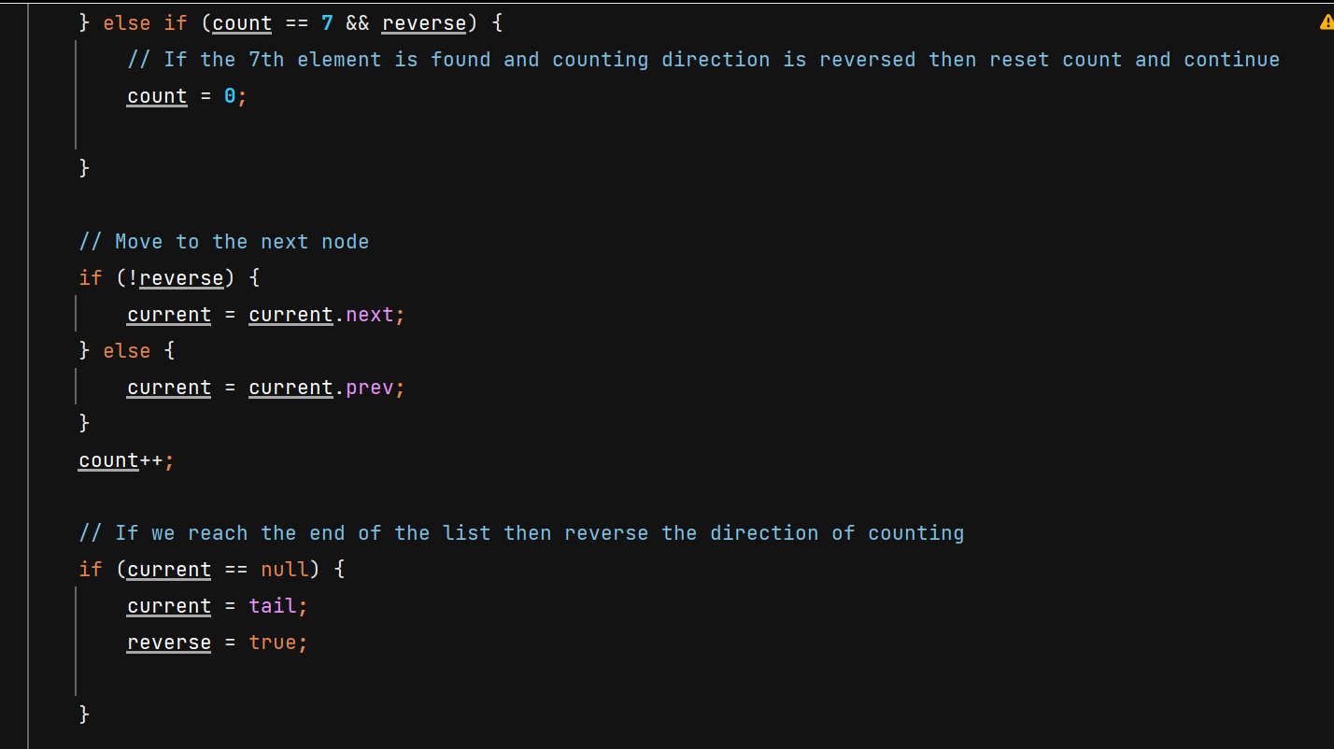

Task4:
I implemented a method called InsertAlternate(DLL<T> newList) to alternately insert elements from another doubly linked list into the calling list. The method ensures that both lists have the same length before continuing. It then iterates through the two lists simultaneously, inserting elements from the available list into the calling list. I also implemented the size() method to use.

Output:
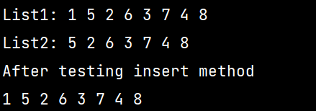
Code:
